Donald Trump uses celebries in the 2020 election campaign

matt george
Department of Communication, Hawaii Pacific University, Honolulu, USA¹
soyoung bae
andrew kwon
School of Digital Media, Kyungsung University, Busan, Korea² ³

Abstract (Font: Arial, Font size 12)
(Font: Arial, Font size:9)
This article examines the 2020 American presidential election in which the Republican Party took office under the leadership of Donald Trump. Celebrity was a dominant theme during the campaign, applied by the Republican Party to discredit Trump by playing on his powerful leaderships and ‘new masculinity’. We argue that the effects of celebrity politics on election campaign must be studied within the context of cultural attitudes towards celebrity, media exposure of candidates and political parties prior to the election campaign, previous campaigns, the duration of the official campaign as well as the existence of the ‘permanent campaign’ on the part of governments, and the dynamics of the celebrity theme as the campaign progresses.
Keywords: Celebrity, Political Communication, Election Campaign, Donald Trump

- Introduction (Font: Arial, Font size 12 B)

(FONT: ARIAL, FONT SIZE 10)
Celebrity is a condition of fame and broad public recognition of an individual or group, or occasionally a character or animal, as a result of attention given them by mass media. A person may attain a celebrity status from having great wealth, their participation in sports or the entertainment industry, their position as a political figure, or even from their connection to another celebrity. 'Celebrity' usually implies a favorable public image, as opposed to the neutrals 'famous' or 'notable', or the negatives 'infamous' and 'notorious'. Celebrity influence in politics, also referred to as "celebrity politics," or "political star power," is the act of a prominent person using their fame as a platform to influence others on political issues or ideology.
AJOCI's new manuscript submission template aims to provide consistent styles for use across JPBC publications. If you are new to publishing with AJOCI, this document is a valuable guide to the process of preparing your work for publication. If you have published with AJOCI before, this document provides insight and instruction into the current process for preparing` your manuscript.
This submission template allows authors to submit their papers for review to an AJOCI. The AJOCI “Submission Template” is a single column MS-Word document that allows authors to type their content into the pre-existing set of paragraph formatting styles applied to the sample placeholder text here, or copy-and-paste their text and then apply the respective paragraph styles.

- Method
This study used eye tracking experiment technology for monitoring dog’s behavior. Authors need to explain the research method in detail, which includes experiment setting and sample characteristics.
  - Tables
Authors can insert tables. Every table must have a caption (title) above it, which must have the “Table Caption” style applied. Please note that tables should not be supplied as image files, but if they are images they must have the “Image” style applied. As an example, Table 1 shows all the styles available in this template, to be applied to the respective element of your text.
Table 1: Styles available in the Word template
Category | Number | %
Gender
Male | 24 | 52.2
Female | 22 | 47.8
Age |  | 54.3
20-24 | 25 | 28.3
25-29 | 13 | 17.4
Older than 30 years | 8
Education
University student | 27 | 58.7
Non university student | 19 | 41.3
Visual aids
Wearing glasses or contact lens | 12 | 26.1
No wearing visual aids | 34 | 73.9
  - Figures
Figures should be inserted after their first text reference, and have specific styles for identification. Insert a figure and apply the “Image” paragraph style to it. For the figure caption, apply the style “Figure Caption.”
To accommodate readers with color vision differences, figures should still be usable when printed in grayscale. Refer to elements of the figure with non-color terms, for example “indicated as squares” instead of “indicated in blue”. Use different patterns in bar charts, different line patterns in graphs, and different shapes in plots to distinguish groups of elements and reinforce color differences.
    - Figure 1.
Figure 1 is an example of a figure and caption spanning the half-page width (one column in a two column format) with the styles applied. If your figure contains third-party material, you must clearly identify it as such, as shown in the example below.

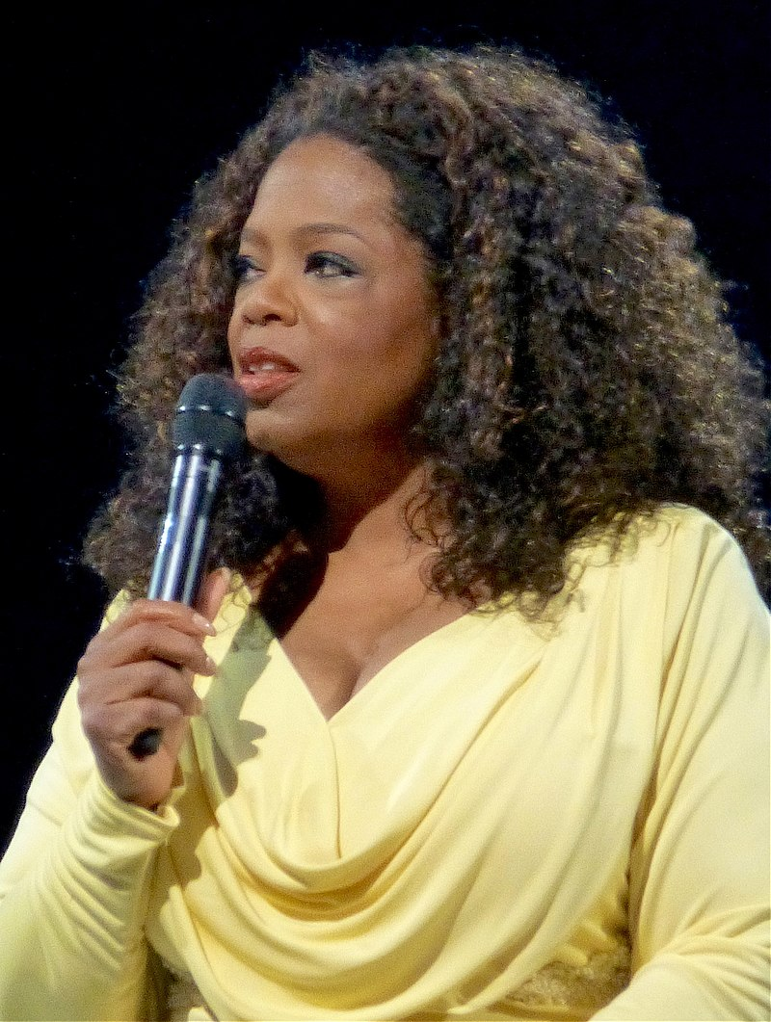
Figure 1: Celebrity such as Oprah Winfrey endorsed presidential campaign in 2008
- Result
The result found the strong articulation about cognitive power of pet.

  - Quotations and Extracts
There are styles for block quotations, which should be used for quotes that are separated from in-line text. Below is an example.
“Celebrities such as movie stars, professional athletes, musicians, and reality television stars have campaigned for and against political parties, candidates, and on political issues. Examples include Oprah Winfrey and George Clooney endorsing Barack Obama's presidential campaign in 2008 and a song written by American musician Hank Williams Jr. endorsing Senator John McCain's campaign in the same election.” (Kim, 2010)

  - Equations
There are two types of math equations: the numbered display math equation and the un-numbered display math equation. Below are examples of both.

    - DisplayFormula.
The DisplayFormula style is applied in the numbered math equation. A numbered display equation always has an equation number (label) on the right.
$\frac{x=-b±\sqrt{b^{2}-4ac}}{2a}$ (1)
    - DisplayFormula.Unnum.

The DisplayFormulaUnnum style is applied only in unnumbered equations. An unnumbered display equation never contains an equation number Bertot and Grimes (2012) on the right—this element distinguishes it from the numbered equation.
$$\frac{x=-b±\sqrt{b^{2}-4ac}}{2a}$$
Please note: the subsequent text after the DisplayFormula (numbered equation) or DisplayFormulaUnnum (unnumbered equation) must have the paragraph style ParaContinue applied.

  - References
AJOCI prefer APA referencing style providing author(s) name(s), journal title/book title, chapter title/article title, year of publication, volume number, book chapter and the article number or pagination. Use of DOI is highly encouraged. You are referred to the Publication Manual of the American Psychological Association, Sixth Edition. Details concerning this referencing style can be found at
http://linguistics.byu.edu/faculty/henrichsenl/apa/apa01.html
References list should be arranged first alphabetically and then further sorted chronologically if necessary. More than one reference from the same author(s) in the same year must be identified by the letters 'a', 'b', 'c', etc., placed after the year of publication.

ACKNOWLEDGMENTS
Acknowledgments are placed before the references. Add information about grants, awards, or other types of funding that you have received to support your research.

REFERENCES
Mortensen, M. (2020). De-celebrification: beyond the scandalous. Cambridge: Cambridge University Press.
Benoit, W.L. (1997). Hugh grant’s image restoration discourse: an actor apologizes, In B. W. Ritchie, P. Burns & C. Palmer (Eds.), Tourism research methods: integrating theory with practice. Wallingford, UK: CABI Publishing.
Kacen J.J. & Lee, J.A. (2002). The Influency of culture on consumer impulsive buying behavior, Journal of Consumer Psychology, 12(2), 163-176.
Johnston, A. M., Huang, Y., & Santos, L. R. (2018). Dogs do not demonstrate a human-like bias to defer to communicative cues. Learning & Behavior, 34(2), 1-15.
Lai, C.W. (2010). How financial attitudes and practices influence the impulsive buying behavior of college and university students. Social Behavior and Personality, 38(3), pp. 373-380.
Morgante, J. D., Zolfaghari, R., & Johnson, S. P. (2012). A critical test of temporal and spatial accuracy of the Tobii T60XL eye tracker. Infancy, 17(1), 9-32.
National Museum of Australia. (2015). A powerful symbol from the centre of Australia, Uluru. from http://www.nma.gov.au/exhibitions/symbols_of_australia/uluru
Shukla, P. (2011). Impact of interpersonal influences, brand origin and brand image on luxury purchase intentions: Measuring functional interactions and a cross-national comparison. Journal of world business, 46(2), 242-252.
Wang, Y. J., Hernandez, M. D., Minor, M. S., & Wei, J. (2012). Superstitious beliefs in consumer evaluation of brand logos: Implications for corporate branding strategy. European journal of marketing, 46(5), 712-732.

. Place the footnote text for the author (if applicable) here.
. Place the footnote text for the author (if applicable) here.
. Place the footnote text for the author (if applicable) here.

