The multifaceted nature of Theme park

Gildong Hong1
Department of Industrial Design, Hangook University, Seoul, Korea¹
Steve Design2
James Research3
Strategic Design Management, Parsons, The New School for Design, New York, USA² ³

Abstract (Font: Arial, Font size 12)
(Font: Arial, Font size:9)
Theme park is multifaceted by nature and various disciplinarians involve in. This study aims to articulate theme and amusement park within the context of each disciplinary including engineering, design, tourism, psychology, geography, marketing and humanities. This is the abstract. This submission template allows authors to submit their papers for review to ITAPS Journals without any output design specifications incorporated at this point in the process. The ITAPS manuscript template is a single column document that allows authors to type their content into the pre-existing set of paragraph formatting styles applied to the sample placeholder text here. Throughout the document you will find further instructions on how to format your text.
Keywords: Theme park, Amusement park, Engineering, Design, Tourism, Psychology, Geography, Marketing

- Introduction (Font: Arial, Font size 12 B)

(FONT: ARIAL, FONT SIZE 10)
The multifaceted nature of theme and amusement park require various disciplines to involve. Ray and Pat Browne define a theme park as “A social artwork designed as a four-dimensional symbolic landscape, evoking impressions of places and times, real and imaginary” (King, 2002) For example, attraction development needs engineering and design approaches, visitor experience and behavior require tourism management perspectives, as well as theme park aims to evoke messages and needs arts and linguistic approaches
ITAPS's new manuscript submission template aims to provide consistent styles for use across ITAPS publications. If you are new to publishing with ITAPJ, this document is a valuable guide to the process of preparing your work for publication. If you have published with ITAPJ before, this document provides insight and instruction into the current process for preparing` your manuscript.
This submission template allows authors to submit their papers for review to an ITAPS. The ITAPS “Submission Template” is a single column MS-Word document that allows authors to type their content into the pre-existing set of paragraph formatting styles applied to the sample placeholder text here, or copy-and-paste their text and then apply the respective paragraph styles.

- Method
This study used eye tracking technology. Authors need to explain the research method in detail, which includes experiment setting and sample characteristics.
  - Tables
Authors can insert tables. Every table must have a caption (title) above it, which must have the “Table Caption” style applied. Please note that tables should not be supplied as image files, but if they are images they must have the “Image” style applied. As an example, Table 1 shows all the styles available in this template, to be applied to the respective element of your text.
Table 1: Styles available in the Word template
Category | Number | %
Gender
Male | 24 | 52.2
Female | 22 | 47.8
Age |  | 54.3
20-24 | 25 | 28.3
25-29 | 13 | 17.4
Older than 30 years | 8
Education
University student | 27 | 58.7
Non university student | 19 | 41.3
Visual aids
Wearing glasses or contact lens | 12 | 26.1
No wearing visual aids | 34 | 73.9
  - Figures
Figures should be inserted after their first text reference, and have specific styles for identification. Insert a figure and apply the “Image” paragraph style to it. For the figure caption, apply the style “Figure Caption.”
To accommodate readers with color vision differences, figures should still be usable when printed in grayscale. Refer to elements of the figure with non-color terms, for example “indicated as squares” instead of “indicated in blue”. Use different patterns in bar charts, different line patterns in graphs, and different shapes in plots to distinguish groups of elements and reinforce color differences.
    - Figure 1.
Figure 1 is an example of a figure and caption spanning the half-page width (one column in a two column format) with the styles applied. If your figure contains third-party material, you must clearly identify it as such, as shown in the example below.

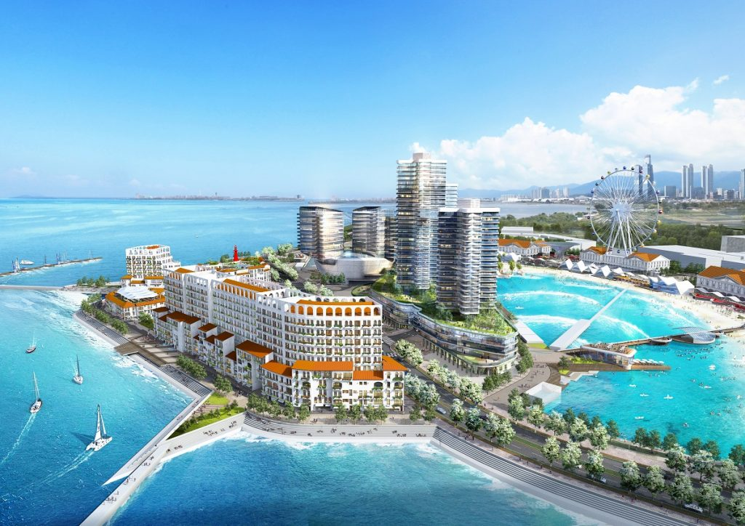
Figure 1: Wave park in Korea. Photograph by Wave garden, via wavepoolmag (https://wavepoolmag.com/the-worlds-largest-wave-pool-breaks-ground-in-south-korea/)

- Result
The result found the strong articulation between theme park and each industry.

  - Quotations and Extracts
There are styles for block quotations, which should be used for quotes that are separated from in-line text. Below is an example.
“The state-of-the-art machinery can produce millions of waves per year and is designed to recover part of the energy used in the wave generation process to attain the lowest possible energy consumption. The innovative water treatment system, developed specifically for wave lagoons, will keep the water transparent and clean throughout the year.” (Wavegarden, 2020)

  - Equations
There are two types of math equations: the numbered display math equation and the un-numbered display math equation. Below are examples of both.

    - DisplayFormula.
The DisplayFormula style is applied in the numbered math equation. A numbered display equation always has an equation number (label) on the right.
$\frac{x=-b±\sqrt{b^{2}-4ac}}{2a}$ (1)
    - DisplayFormula.Unnum.

The DisplayFormulaUnnum style is applied only in unnumbered equations. An unnumbered display equation never contains an equation number Bertot and Grimes (2012) on the right—this element distinguishes it from the numbered equation.
$$\frac{x=-b±\sqrt{b^{2}-4ac}}{2a}$$
Please note: the subsequent text after the DisplayFormula (numbered equation) or DisplayFormulaUnnum (unnumbered equation) must have the paragraph style ParaContinue applied.

  - References
ITAPJ prefer APA referencing style providing author(s) name(s), journal title/book title, chapter title/article title, year of publication, volume number, book chapter and the article number or pagination. Use of DOI is highly encouraged. You are referred to the Publication Manual of the American Psychological Association, Sixth Edition. Details concerning this referencing style can be found at
http://linguistics.byu.edu/faculty/henrichsenl/apa/apa01.html
References list should be arranged first alphabetically and then further sorted chronologically if necessary. More than one reference from the same author(s) in the same year must be identified by the letters 'a', 'b', 'c', etc., placed after the year of publication.

ACKNOWLEDGMENTS
Acknowledgments are placed before the references. Add information about grants, awards, or other types of funding that you have received to support your research.

REFERENCES
Asimakopulos, A. (1991). Keynes's general theory and accumulations. Cambridge: Cambridge University Press.
Beeton, S. (2005). The case study in tourism research: A multi-method case study approach. In B. W. Ritchie, P. Burns & C. Palmer (Eds.), Tourism research methods: integrating theory with practice. Wallingford, UK: CABI Publishing.
Kacen J.J. & Lee, J.A. (2002). The Influency of culture on consumer impulsive buying behavior, Journal of Consumer Psychology, 12(2), 163-176.
King, M. J. (2002). The theme park: Aspects of experience in a four-dimensional landscape. Material Culture, 34(2), 1-15.
Lai, C.W. (2010). How financial attitudes and practices influence the impulsive buying behavior of college and university students. Social Behavior and Personality, 38(3), pp. 373-380.
Morgante, J. D., Zolfaghari, R., & Johnson, S. P. (2012). A critical test of temporal and spatial accuracy of the Tobii T60XL eye tracker. Infancy, 17(1), 9-32.
National Museum of Australia. (2015). A powerful symbol from the centre of Australia, Uluru. from http://www.nma.gov.au/exhibitions/symbols_of_australia/uluru
Shukla, P. (2011). Impact of interpersonal influences, brand origin and brand image on luxury purchase intentions: Measuring interfunctional interactions and a cross-national comparison. Journal of world business, 46(2), 242-252.
Wang, Y. J., Hernandez, M. D., Minor, M. S., & Wei, J. (2012). Superstitious beliefs in consumer evaluation of brand logos: Implications for corporate branding strategy. European journal of marketing, 46(5), 712-732.

. Place the footnote text for the author (if applicable) here.
. Place the footnote text for the author (if applicable) here.
. Place the footnote text for the author (if applicable) here.

